2016 Anderson County High School
Archery Clinic
(To be held at ACHS Archery Practice Gym in the Freshman Wing)

Tuesdays September 13th, 20th & 27th 2016 from 5:30 to 7:30 pm

Cost is $30 per archer ($20 for second archer in a family)
(This clinic is open only to children attending Anderson County Schools)

This will be an introduction to the NASP (National Archery in the Schools Program) that is taught at Elementary, Middle and High Schools (4th thru 12th grades)

For advance archers, you will receive additional instruction on archery techniques that focus on release, follow through, aiming, mental aspects.

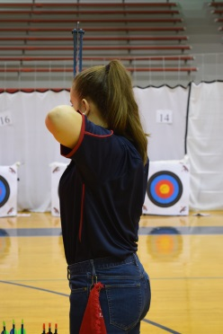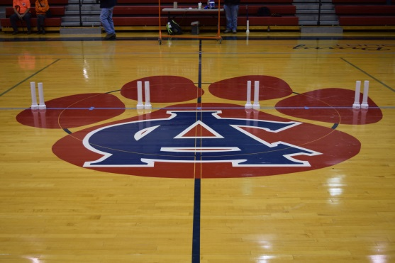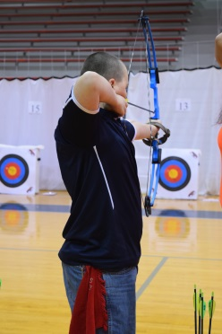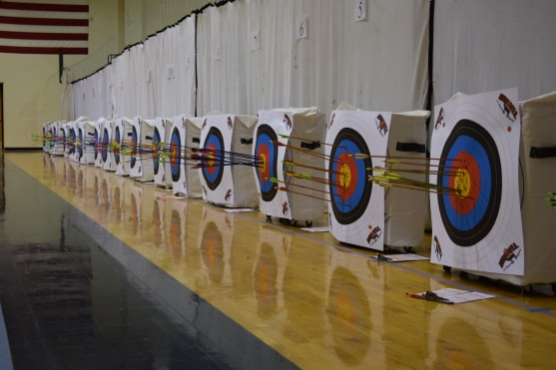

We will have the coaches on hand from the various schools as well as archers from the ACHS BearCat Archery Team

For registration or more information:
Dave Frederick – (502) 545-3728 – email: dave.frederick85@yahoo.com

Please make all checks out to: Anderson County HS Archery Team

