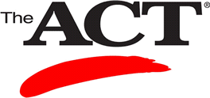

Back by popular demand…Sullivan University’s **2-Day ACT Review Course**

***The Sullivan University ACT review is held on the Saturday and Sunday one week prior to the National ACT test date. All students will receive 4 hours of ACT preparation in English and Reading and 4 hours of ACT preparation in Math and Science. Lunch will be provided. There is a cap of 80 students per weekend.***

***The cost for both days is $80.00***

***Lunch and study guide with CD are included.***

***Future ACT Prep dates:***

***Oct. 18 – 19, 2014 10:00 AM until 2:30 PM***

***Dec. 6 -7, 2014 10:00 AM until 2:30 PM***

***Jan. 31 – Feb. 1, 2015 10:00 AM until 2:30 PM***

***For registration see your counselor for a***



***registration form or contact Carole Schochler***

***at: 859-514-7649 or cschochler@sullivan.edu***