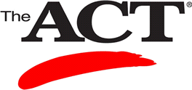
Back by popular demand…Sullivan University’s 2-Day ACT Review Course

The Sullivan University ACT review is held on the Saturday and Sunday one week prior to the National ACT test date. All students will receive 4 hours of ACT preparation in English and Reading and 4 hours of ACT preparation in Math and Science. Lunch will be provided. There is a cap of 80 students per weekend.

The cost for both days is $80.00
Lunch and study guide with CD are included.

Future ACT Prep dates:

Oct. 8 - 9, 2016 10:00 AM until 2:30 PM

Dec. 3 - 4, 2016 10:00 AM until 2:30 PM

Feb. 18 - 19, 2017 10:00 AM until 2:30 PM (JUNIORS ONLY!)

You can register for these classes by going to

http://sullivan.edu/act-prep/
Sign up today…classes fill up quickly!

