2017 PROJECT GRADUATION
ANDERSON COUNTY HIGH SCHOOL SENIORS
MULCH GALA

$4.00 PER BAG FOR 2.0 CUBIC FOOT – Prepayment at the time of order.
Pickup will be Saturday, April 15, 2017 from 8:00 am to 12:00 pm at the Anderson County High School parking lot
Please make checks payable to 2017 Project Graduation.

Seller Name________________________ Phone#____________________________

NAME OF BUYER:______________________________________________________

ADDRESS OF BUYER:____________________________________________________

CITY:___________________________________PHONE #:______________________
River Valley Mulch-All Natural Forest Material coming from Flemingsburg, KY
(Mulch provided by McInturf local Sawmill & Kiln)
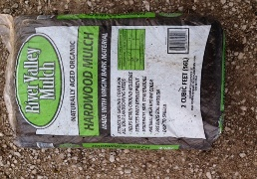
Naturally Aged Organic – Virgin Bark Material
Number of Bags ______________

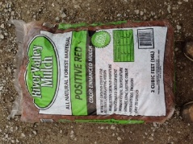
RED
Number of Bags _____________

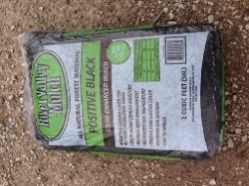
BLACK
Number of Bags _____________

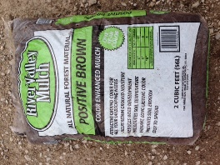
Brown
Number of Bags_______________
1=$ 4.00 6=$24.00 11=$44.00 16=$64.00 21=$ 84.00 30=$120.00 55=$220.00 80=$320.00
2=$ 8.00 7=$28.00 12=$48.00 17=$68.00 22=$ 88.00 35=$140.00 60=$240. 00 85=$340.00
3=$12.00 8=$32.00 13=$52.00 18=$72.00 23=$ 92.00 40=$160.00 65=$260.00 90=$360.00
4=$16.00 9=$36.00 14=$56.00 19=$76.00 24=$ 96.00 45=$180.00 70=$280.00 95=$380.00
5=$20.00 10=$40.00 15=$60.00 20=$80.00 25=$100.00 50=$200.00 75=$300.00 100=$400.00

For more information, please email lashearer1@roadrunner.com or call Linda Shearer @ 502 839-1227.

